Title (18 pt)
Author Name¹, Author Name ²∗, Author Name ³
¹ Adress, E-mail
² Corresponding author : Turkish Airlines, Turkish Aviation Academy, Yesilkoy, İstanbul, Turkey, herdun@thy.com
³ Marmara Clean Air Center, Ministry of Environment and Urbanization, Nisantaşı, 34365, Istanbul, Turkey, ozzqa@hotmail.com
Abstract
Turkey has had significant improvements in her economy over the last decades. Although, Turkey's air quality constantly improves every year, air pollution problem still continues in Turkey. Descriptive statistics was carried out for three years hourly average of PM10, SO₂, NO₂ and O₃ concentrations of 16 metropolitan cities in Turkey. The frequency distribution of daily average of PM10 concentration of all cities occurs within 59% at 20–60 µgm⁻³ range. Daily average of SO₂ concentration is about 84% below 20µgm⁻³. The study also indicated that 44% of NO₂ and 59% of O₃ were below the levels of 45 µgm⁻³ and 30 µgm⁻³, respectively. The result of this study is expected to benefit the legislators, scientists and government personnel about controlling and reducing emissions by developing a long-term air quality management strategy and create more public awareness for the prevention of consumption.
Keywords: Urbanization, air pollution, health, metropolitan.

1. Introduction
Humanity has recognized that air pollution is a major social concern since several decades. Industrialization, urbanization and land degradation decrease the level of air quality, because of air pollutants originating from industrial activities and vehicles concentration in populated areas. Air quality is a complex phenomenon due to its sources, atmospheric conditions and interaction of many factors. It is relatively easy to see or smell poor food and water quality, but air quality is not easily recognized. People eat and drink several times a day, but they have to breathe every moment in order to live. Therefore, the air quality level is very important for the human life. Air pollution originates from different sources within urban and suburban areas and it is also transported from long distances. It is considered one of the major problems in populated urban areas with many consequences for humans such as health issues, global warming and regional climate change. Urban air pollution is a problem for both the developed and developing countries of the world (Gurjar et al., 2008). The use of technology in everyday life steadily increases parallel to the income level of the population, which lead to growth in the energy consumption and vehicle usage causing greater demand for fossil fuels with an associated consequent in urban pollution. Industrialization and modernization lead to greater urban expansion with each passing day. Quality of food, water and air are very important for a reasonable and sustainable life and environment. People want to become healthier through what they eat and drink, as well as the quality of the air they breathe. Air quality investigations and information sharing with the public will lead to finding possible solutions to the air pollution problem. People should be aware of the air-borne carcinogen-containing pollutants. In order to assess the negative impacts of air pollution, the implementations of selected pilot studies must be considered on the scientific and technological basis. Breathing in clean air is vital for better health and this could be achieved by effective solution for the air pollution problem, which is the aim of this study.
Air pollution is certainly not a new phenomenon and its negative effect on health dated as far back as the early ages. For example, one thousand years ago a philosopher and physician Avicenna (IbnSina) emphasized in his books, the effects of pollution on health (Byrne, 2008). Extensive fossil fuel consumption in almost all human activities led to some undesirable phenomena such as atmospheric and environmental pollution, which have not been experienced before in human history (Şen, 2004). Air pollution in a region is a complex phenomenon that varies in time and space and results from different sources; topographical, meteorological and anthropogenic activities (Şen, 1998). When air pollution levels are low, usually far away from sources and rural areas, their negative effects are said to have chronic effects on health over a long period of time. However, extreme concentrations of pollutants, usually seen nearby in the urban areas, can have catastrophic effects on people's health and may also lead to changes in the world ecosystem (Ercelebi and Toros, 2009; Saylan et al., 2011). Therefore, the statistics of air quality levels permits the assessment of their contribution to overall air pollution. Mayer (2009) emphasized that most cities of the world suffer from serious air quality problems and that the major probable reasons for this is urban population growth, combined with a change in land use due to increasing urbanization. On the other hand, Baldasano et al. (2003) who studied air quality data from large cities, present an assessment of the air quality for the principal cities in developed and developing countries. According to their study, particulate matter is a major problem in almost all of the Asia, exceeding 300 µgm⁻³ in many cities. The investigation by Parekh et al. (2001) has clearly shown that different cities in different geographical areas of the world have a very high particulate loading in their ambient air. Kindap et al. (2006) investigated the trans-boundary particulate matter transport from Eastern European countries to Turkey. Their study demonstrated that the impact of emissions from Eastern Europe to PM10 concentrations in Istanbul may be significant under certain meteorological conditions. They highlighted that on the average, transport accounts for a small percentage of PM10 levels in Istanbul, but at times, it can constitute about one quarter of Istanbul’s PM pollution during the simulated period. Unal et al. (2011) have analyzed PM10 concentration data collected at 10 stations in the Istanbul Municipality area for the period of 2005-2009. They focused on the spatial and temporal variations of the pollutants and their possible sources. The PM10 concentrations in Istanbul showed significant variations across the city with PM10 levels at several traffic hot spots and industrial zones exceeding European Community (EC) air quality limits. Their study indicated that the general temporal pattern is characterized by high concentrations in winter and lower concentrations in summer. The number of occasions when levels exceeded EU limits was surpassed at all the monitoring sites during the analyzed years, which reﬂects the serious pollution problem in the biggest city of Turkey. Ozdemir et al. (2012) have analyzed the effect of traffic emission at the playgrounds close to a road. According to their study, half of the population lives in the urban environments where air pollution has become one of the most critical issues for human health in the world and unfortunately, children are more susceptible to air pollution than adults since they inhale and retain larger amounts of air pollutants per unit of body weight in cities.
In this study, the data are analyzed and presented in relation to environmental contamination and health with result from a set of representative sample of air quality data concentrations of monitoring stations in sixteen metropolitan areas of Turkey. These results demonstrate background air pollution levels and variability in metropolitan areas but future studies forecasting air quality levels are important for human health sustainability in order to prevent health effects.
2. Study Area, Data and Methodology
Turkey is located, between latitude 35º and 42° north and between longitude 26º and 44° east, on the border between two continents of Europe and Asia. It has a significant geostrategic importance for general air circulation between Europe, Asia and Africa. Turkey covers an area of 783 562 km² with an increasing business and convention centers. It’s one of the world's newly industrialized countries and her diplomatic initiatives led to her recognition as a growing regional power in the World. Turkey is surrounded by coastal borders with the Mediterranean Sea, the Aegean Sea and the Black Sea and by the land borders of Greece, Bulgaria, Armenia, Azerbaijan, Georgia, Syria, Iraq and Iran (Fig. 1). As a Mediterranean country with four distinct seasons, the climatic conditions are quite temperate. The coastal region climate is moderate with greater precipitation and the interior part has Anatolia Plateau with hot summers and cold winters and limited rainfall (Toros, 2012). Turkey’s population is approximately 75 million and the annual population growth rate in 2011 was 1.35% (TUIK 2012). According to the 1927 census 76% of the population lived in villages and 24% lived in cities. However, the 2011 census indicated that 77% of Turkey’s population lived in urban areas and 23% in the villages (Fig. 2). There are 81 provinces, 16 of them are metropolitan municipalities (cities having population more than 750 thousand), and there is at least one air quality monitoring station in all provinces, although the number of stations is increasing rapidly. The population of the metropolitan and dependent areas is approximately 43 million (about 57% of the population of Turkey). The remainder, 88% are in provincial and district centers and only 12% live in towns and villages (TUIK, 2012).
Figure 1. Map of Turkey and location of the metropolitan areas.
There are two main sources affecting air quality in Turkey; one is the regional sources, and the other is long range transportation from Africa (desert dust) and Europe, due to the atmospheric circulation patterns (Kindap et al., 2006). Herein, we analyzed daily average concentrations of PM10, SO₂, NO₂ and O₃ between 1 January 2010 and 31 December 2012. After quality control, the number of stations providing acceptable data was 47 for PM10; 50 for SO₂; 22 for NO₂ and 10 for O₃ measurements. The data analysis was based on 24 hours averages concentrations. Calculations were made if the concentration measurements are available at least 18 hours for each day. The ambient air quality stations operated on a continuous basis under the supervision of the Ministry of Environment and Urbanism.
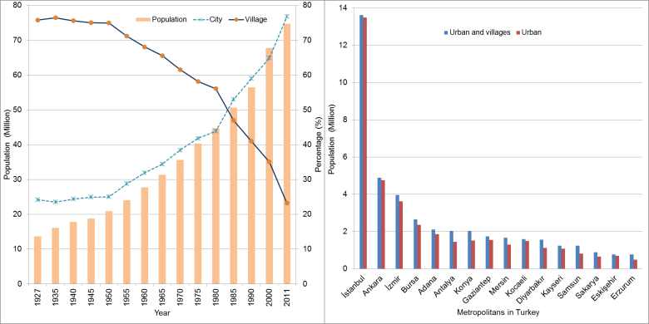
Figure 2. Population of Turkey and percentage occupation of cities and villages with time (left panel) and the population of metropolitan and dependent areas (right panel).
To obtain additional information on the level of air quality in metropolitan areas, a descriptive statistical analysis was performed on the daily average air pollution data. During this study various air quality data from a number of stations (NS) were analyzed with daily available data (DAD) identifying maximum values (Max), 95% percentile (95%), 75% percentile (75%), Average, 25% percentile (25%), 5% percentile (5%), minimum (Min), standard deviation (Std), coefficient of skewness (Skw), finally coefficient of kurtosis values (Kur) and daily limit exceeding percentage of PM10 (>50%). We calculated skewness and kurtosis to obtain additional information on the shape of a probability distribution of air pollution data. A symmetrical distribution has a skewness of zero, a positive value of skewness has a long tail extending to the right whereas a negative value of skewness has a long tail extending to the left. Kurtosis measures whether the data are peaked or flat relative to a normal distribution. A normal distribution has a kurtosis of 3, a positive kurtosis indicates peak whereas a negative kurtosis indicates flat distribution.
3. Results and Discussion
People’s health can be adversely affected by exposure to air pollutants such as PM10, SO₂, NO₂ and O₃, which comes from a wide variety of sources like burning of fossil fuels, industries, long-range transportation. The effects of pollutants over the long-term (the average value is important) are seen in chronic disease and the consequence of catastrophic high levels of air pollution in the short-term can lead to penetrative respiratory effects (maximum value is important). Thus, some groups could be more sensitive to pollutants than others like children, older adults or some with health problems like asthma. Direct and indirect effects of pollutants vary from one place to another depending on pollutant concentrations and population density. In Turkey, the average number of people per square kilometer is about 97 and the most densely populated areas are; İstanbul with 2 622 per km², Kocaeli with 443, İzmir with 330, Gaziantep with 257, Bursa with 254, to the least populated area, Tunceli with 11 people per km² (TUIK 2012).
3.1 The statistical characteristics of PM10 concentration
The concentrations of air pollution vary inherently with time and space, and usually, increase in metropolitan areas due to human activities. The main air pollution parameter is particulate matter (PM10), which originates from complex variety of sources like mixture of mineral components, salt, heavy metals, organic and elemental carbon with wide range of sizes. Quality of life in metropolitans also depends on their air quality levels. The statistical characteristics of ambient PM10 concentration are given in Table 1, which shows the general picture of pollution levels in 16 metropolitan areas of Turkey.
The data were obtained from 47 monitoring stations in 16 metropolitan areas over a three-year period. Thus, it is possible to compare the characteristics of PM10 concentrations during 2010 and 2012. According to Table 1, some metropolitan areas have more than one NS (number of stations). For instance, İstanbul has 10, İzmir has 8; Ankara has 7; Adana has 4; Kayseri and Kocaeli have 3; and Konya and Samsun have 2 measurement stations. The number of days with available data (DAD) ranged were between 1084 (Ankara) and 502 (Bursa). The daily PM10 values vary from one city to another, for example, the daily maximum value observed in Gaziantep was 631 µgm⁻³, whereas in Samsun it was 115 µgm⁻³. Descriptive statistics and the frequency distribution of the average values of PM10 concentrations from 47 air quality stations are shown in Fig. 3. The average of the daily maximum value of all 47 stations were 62 µgm⁻³ with a maximum 93 µgm⁻³ in Gaziantep and minimum 32 µgm⁻³ in Eskişehir.
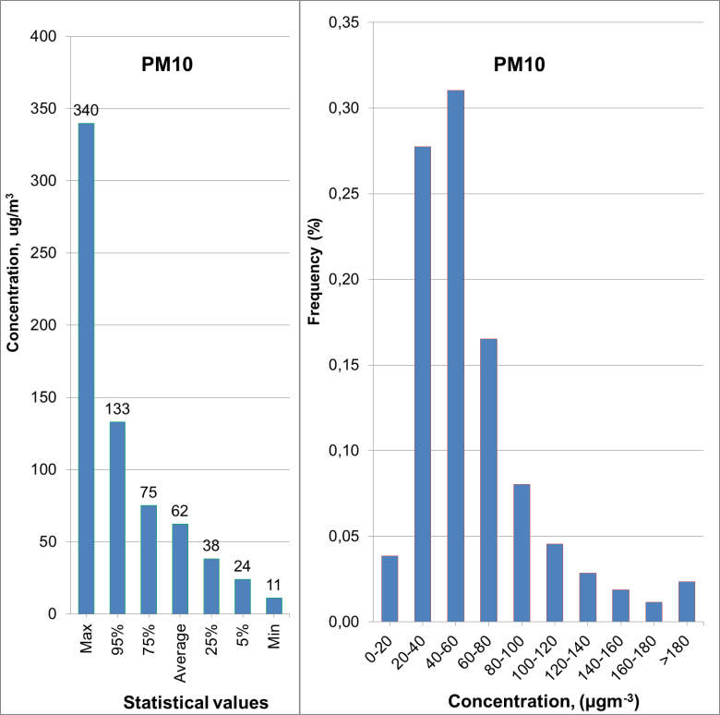
Figure 3. Descriptive statistical values (left panel) and frequency distribution of average value of PM10 concentration (right panel).
Average PM10 value has a rapid drop from the maximum 340 µgm⁻³ to the minimum 11 µgm⁻³ with 95%, 75%, 25% and 5% percentiles, which correspond to 133 µgm⁻³, 75 µgm⁻³, 38 µgm⁻³ and 24 µgm⁻³, respectively. However, 5th-95th and 25th-75th percentile values are 111 µgm⁻³, 37 µgm⁻³, respectively. The EU standard limit value (50 µgm⁻³) exceeding the percentage of PM10 occurred as a minimum in Eskişehir (11%) and as a maximum in Sakarya (81%) with overall average value as 51%. Generally, the results show that the highest PM10 values appear in Gaziantep and Sakarya. On the other hand, Eskişehir and Samsun had the lowest PM10 concentrations. The lower and higher standard deviations are 16 µgm⁻³ and 63 µgm⁻³ for Samsun and Gaziantep, respectively, with the average of 37 µgm⁻³ in the metropolitan areas. The highest and lowest skewness values are 1 µgm⁻³ and 6 µgm⁻³, respectively. The average skewness value is 2 µgm⁻³, that means lower PM10 values are dominant. The coefficient of skewness for all stations is positive, which means that the frequency distribution has a long tail extending the higher values (Fig. 3, right panel). Furthermore, the coefficient of kurtosis positive values were 1 µgm⁻³, 12 µgm⁻³and 67 µgm⁻³, for minimum, average and maximum values, respectively. These kurtosis values imply that the distribution has a sharp peak and relative concentration in the center (see Table 1). The frequency distribution of PM10 concentrations are also given in Table 1 for intervals of 20 µgm⁻³. A peak in the distribution of daily PM10 concentration occurs most frequently as 31% within 40-60 µgm⁻³ range and then 28% in the range 20-40 µgm⁻³, 16% between 60–80 µgm⁻³, 8% within the range, 80–100 µgm⁻³, 5% in the range of 100–120 µgm⁻³, 4% within the range of 0–20 µgm⁻³ and the remainder were more than 120 µgm⁻³ (Fig. 3, right panel).

Table 1. Descriptive statistical values (left panel) and frequency distribution of average value of PM10 concentration (right panel).
PM10 |  | Descriptive statistics |  |  |  |  |  |  |  |  |  |  |  |  | Frequency histograms
City | NS | DAD | Max | 95% | 75% | Average | 25% | 5% | Min | Std | Skw | Kur | >50 % |  | 0-20 | 20-40 | 40-60 | 60-80 | 80-100 | 100-120 | 120-140 | 140-160 | 160-180 | >180
Adana | 4 | 1079 | 343 | 92 | 60 | 52 | 37 | 21 | 11 | 27 | 3 | 23,9 | 0,45 |  | 44 | 296 | 469 | 178 | 53 | 18 | 7 | 4 | 2 | 8
Ankara | 7 | 1084 | 259 | 155 | 87 | 68 | 38 | 24 | 6 | 42 | 1 | 1,8 | 0,56 |  | 24 | 286 | 285 | 180 | 103 | 70 | 58 | 31 | 21 | 26
Antalya | 1 | 1033 | 287 | 138 | 70 | 61 | 38 | 23 | 11 | 37 | 2 | 5,2 | 0,52 |  | 32 | 255 | 385 | 163 | 82 | 39 | 26 | 18 | 14 | 19
Bursa | 1 | 502 | 217 | 133 | 72 | 60 | 37 | 23 | 7 | 34 | 2 | 3,7 | 0,53 |  | 17 | 137 | 171 | 88 | 38 | 19 | 14 | 7 | 5 | 6
Diyarbakır | 1 | 792 | 555 | 169 | 101 | 82 | 50 | 32 | 13 | 51 | 3 | 18,8 | 0,74 |  | 3 | 90 | 223 | 157 | 119 | 78 | 55 | 20 | 17 | 30
Erzurum | 1 | 1029 | 585 | 150 | 68 | 59 | 30 | 18 | 8 | 50 | 4 | 20,9 | 0,42 |  | 99 | 338 | 264 | 143 | 60 | 37 | 22 | 23 | 9 | 34
Eskişehir | 1 | 827 | 216 | 61 | 40 | 32 | 21 | 11 | 4 | 17 | 2 | 17,3 | 0,11 |  | 202 | 422 | 159 | 31 | 12 | 0 | 0 | 0 | 0 | 1
Gaziantep | 1 | 1047 | 631 | 209 | 123 | 93 | 50 | 21 | 10 | 63 | 2 | 7,5 | 0,74 |  | 45 | 137 | 172 | 191 | 120 | 113 | 67 | 74 | 37 | 91
Mersin | 1 | 995 | 594 | 102 | 70 | 60 | 42 | 27 | 10 | 37 | 6 | 67,3 | 0,57 |  | 14 | 206 | 399 | 230 | 91 | 24 | 11 | 4 | 3 | 13
İstanbul | 10 | 1084 | 161 | 98 | 61 | 50 | 34 | 23 | 9 | 23 | 1 | 1,9 | 0,40 |  | 28 | 421 | 355 | 149 | 84 | 35 | 7 | 4 | 1 | 0
İzmir | 8 | 1084 | 186 | 98 | 58 | 50 | 35 | 25 | 11 | 23 | 2 | 5,1 | 0,39 |  | 19 | 395 | 427 | 136 | 60 | 24 | 14 | 4 | 4 | 1
Kayseri | 3 | 1084 | 297 | 167 | 85 | 69 | 37 | 24 | 16 | 47 | 2 | 3,4 | 0,55 |  | 7 | 334 | 271 | 172 | 102 | 62 | 39 | 33 | 18 | 46
Kocaeli | 3 | 1076 | 207 | 135 | 79 | 65 | 42 | 28 | 17 | 33 | 1 | 1,8 | 0,61 |  | 5 | 238 | 343 | 233 | 102 | 70 | 38 | 22 | 21 | 4
Konya | 2 | 1053 | 422 | 172 | 77 | 65 | 34 | 21 | 12 | 52 | 3 | 9,3 | 0,49 |  | 51 | 335 | 270 | 156 | 82 | 44 | 33 | 22 | 11 | 49
Sakarya | 1 | 986 | 362 | 171 | 98 | 83 | 54 | 39 | 18 | 45 | 2 | 5,3 | 0,81 |  | 1 | 61 | 293 | 266 | 127 | 79 | 61 | 32 | 21 | 45
Samsun | 2 | 1050 | 115 | 77 | 54 | 46 | 34 | 25 | 13 | 16 | 1 | 1,4 | 0,33 |  | 19 | 435 | 419 | 138 | 33 | 6 | 0 | 0 | 0 | 0
Average |  | 988 | 340 | 133 | 75 | 62 | 38 | 24 | 11 | 37 | 2 | 12,2 | 0,51 |  | 38 | 274 | 307 | 163 | 79 | 45 | 28 | 19 | 12 | 23

3.2 The statistical characteristics of SO₂ concentration
Sulphur dioxide (SO₂) has an unpleasant, toxic, sharp smell and can be changed into harmful compounds like sulphuric acid. It is mainly emitted from house heating and industrial activities in metropolitan areas by burning low quality fuels like coals having high sulphur content. Generally, direct effect of SO2 irritates nose and throat. Descriptive statistics are presented for SO₂ concentrations in order to assess its contribution to the levels of air quality. The data were derived from 50 ambient air quality monitoring stations in sixteen metropolitan areas, during the period of 2010 - 2012 and the overall average values are shown in Table 2.
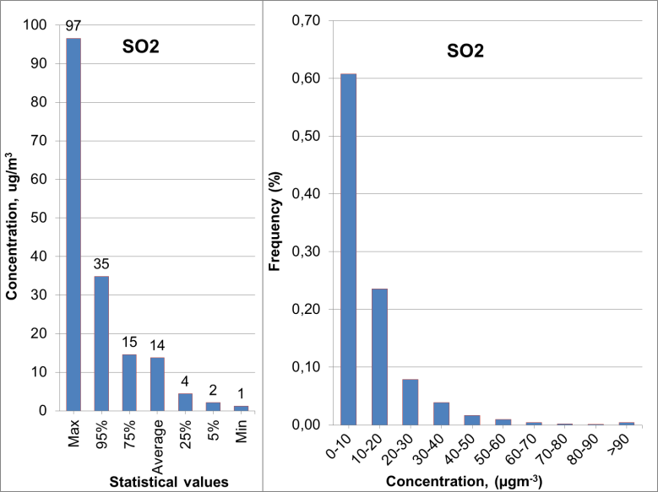
Figure 4. Descriptive statistical values (left panel) and frequency histogram of average value of SO2 data (right panel).
The data of İstanbul, İzmir, Ankara, Adana, Kayseri, Kocaeli, Konya and Samsun are from 10, 8, 8, 4, 3, 3, 2 and 2 stations, respectively and from the other cities only 1 station. The daily maximum SO₂ value changes from city to city with values between 192 µgm⁻³ in Konya and 27 µgm⁻³ in Eskişehir with the overall average maximum value of 97 µgm⁻³. The average of 50 stations is 14 µgm⁻³ with a maximum value of 97 µgm⁻³ and minimum value of 1µgm⁻³. The average SO2 values of 95%, 75%, 25% and 5% percentiles are 35 µgm⁻³, 15 µgm⁻³, 4 µgm⁻³ and 2 µgm⁻³, respectively. On the other hand, 5th-95th and 25th-75th percentiles have mid-values as 33 µgm⁻³, 11 µgm⁻³, respectively. The higher SO₂ values increase sharply. For example, the 75th percentile value is 4 times bigger than 25th percentile (Fig. 4, left panel). The average daily values of all stations change between 7 µgm⁻³ (Mersin) and 19 µgm⁻³ (Konya). According to the Fig. 4 (right panel), the frequency of average value of SO2 data is concentrated in the range of 0-10 µgm⁻³. Approximately, 61% of SO₂ concentrations are below 10 µgm⁻³, but 85% of the data are below 20 µgm⁻³. As seen from Table 2, both skewness and kurtosis values are positive for all cases, which means that the frequency distribution extends to high SO₂ values with a sharper peak.

Table 2. Descriptive statistical values and frequency histogram for SO₂ during 2010-2012.
SO₂ |  | Descriptive statistics |  |  |  |  |  |  |  |  |  |  |  | Frequency histograms
City | NS | DAD | Max | 95% | 75% | Average | 25% | 5% | Min | Std | Skw | Kur |  | 0-10 | 10-20 | 20-30 | 30-40 | 40-50 | 50-60 | 60-70 | 70-80 | 80-90 | 90-100
Adana | 4 | 1081 | 63 | 19 | 8 | 9 | 3 | 2 | 1 | 6 | 3 | 13 |  | 914 | 117 | 44 | 5 | 0 | 0 | 1 | 0 | 0 | 0
Ankara | 8 | 1084 | 77 | 38 | 20 | 17 | 7 | 4 | 2 | 11 | 2 | 4 |  | 422 | 402 | 167 | 51 | 25 | 13 | 3 | 1 | 0 | 0
Antalya | 1 | 852 | 178 | 32 | 12 | 13 | 2 | 1 | 1 | 20 | 5 | 31 |  | 583 | 192 | 33 | 9 | 6 | 5 | 4 | 2 | 3 | 1
Bursa | 3 | 746 | 88 | 48 | 19 | 15 | 3 | 1 | 1 | 14 | 2 | 2 |  | 452 | 121 | 72 | 42 | 28 | 30 | 0 | 0 | 1 | 0
Diyarbakır | 1 | 935 | 71 | 37 | 19 | 17 | 8 | 4 | 1 | 11 | 1 | 1 |  | 419 | 293 | 39 | 161 | 13 | 7 | 2 | 1 | 0 | 0
Erzurum | 1 | 1032 | 124 | 49 | 15 | 16 | 5 | 1 | 1 | 17 | 3 | 10 |  | 622 | 227 | 75 | 33 | 28 | 12 | 13 | 10 | 4 | 5
Eskişehir | 1 | 685 | 27 | 16 | 8 | 8 | 3 | 1 | 1 | 5 | 2 | 4 |  | 596 | 63 | 26 | 0 | 0 | 0 | 0 | 0 | 0 | 0
Gaziantep | 1 | 1058 | 127 | 60 | 18 | 17 | 3 | 1 | 1 | 19 | 2 | 4 |  | 665 | 147 | 69 | 44 | 46 | 37 | 22 | 13 | 10 | 3
Mersin | 1 | 743 | 41 | 21 | 5 | 7 | 1 | 1 | 1 | 6 | 3 | 7 |  | 675 | 30 | 37 | 0 | 1 | 0 | 0 | 0 | 0 | 0
İstanbul | 10 | 1084 | 31 | 17 | 10 | 10 | 4 | 2 | 1 | 5 | 1 | 2 |  | 827 | 233 | 23 | 1 | 0 | 0 | 0 | 0 | 0 | 0
İzmir | 8 | 1084 | 43 | 24 | 13 | 13 | 7 | 5 | 3 | 6 | 2 | 4 |  | 597 | 391 | 72 | 22 | 2 | 0 | 0 | 0 | 0 | 0
Kayseri | 3 | 1028 | 178 | 41 | 20 | 17 | 5 | 3 | 1 | 15 | 4 | 24 |  | 431 | 343 | 146 | 51 | 32 | 10 | 6 | 1 | 2 | 2
Kocaeli | 3 | 1037 | 140 | 38 | 18 | 16 | 6 | 2 | 1 | 16 | 4 | 23 |  | 509 | 320 | 116 | 47 | 18 | 8 | 3 | 4 | 1 | 2
Konya | 2 | 1063 | 192 | 49 | 20 | 19 | 7 | 4 | 1 | 19 | 4 | 22 |  | 503 | 306 | 128 | 51 | 29 | 13 | 9 | 3 | 2 | 4
Sakarya | 1 | 934 | 64 | 30 | 13 | 11 | 2 | 1 | 1 | 10 | 2 | 4 |  | 649 | 182 | 61 | 26 | 13 | 2 | 1 | 0 | 0 | 0
Samsun | 2 | 1044 | 103 | 39 | 18 | 15 | 5 | 2 | 1 | 12 | 2 | 6 |  | 551 | 285 | 109 | 55 | 20 | 16 | 7 | 0 | 0 | 0
Average |  | 968 | 97 | 35 | 15 | 14 | 4 | 2 | 1 | 12 | 3 | 10 |  | 588 | 228 | 76 | 37 | 16 | 10 | 4 | 2 | 1 | 1

3.3 The statistical characteristics of NO₂ concentration
Nitrogen dioxide (NO₂) is an important air pollutant due to its harmful effects on human health. The main sources of NO₂ are automobiles, industrial processes and fuel combustion in power plants. The statistical characters of NO₂ concentration were given in Table 3.

Table 3. Descriptive statistical values and frequency histogram for NO₂ during 2010-2012.
NO₂ |  | Descriptive statistics |  |  |  |  |  |  |  |  |  |  |  | Frequency histograms
City | NS | DAD | Max | 95% | 75% | Averagre | 25% | 5% | Min | Std | Skw | Kur |  | 0-15 | 15-30 | 30-45 | 45-60 | 60-75 | 75-90 | 90-105 | 105-120 | 120-135 | 135-150 | >150
Adana | 2 | 1022 | 320 | 85 | 54 | 44 | 25 | 9 | 3 | 27 | 2,7 | 18 |  | 92 | 285 | 253 | 214 | 91 | 51 | 16 | 7 | 3 | 3 | 7
Ankara | 8 | 1084 | 235 | 122 | 67 | 59 | 37 | 26 | 10 | 29 | 1,8 | 4 |  | 1 | 113 | 327 | 276 | 166 | 80 | 38 | 25 | 21 | 17 | 20
Bursa | 2 | 268 | 86 | 56 | 42 | 33 | 26 | 3 | 3 | 16 | -0,3 | 0 |  | 39 | 48 | 136 | 36 | 8 | 1 | 0 | 0 | 0 | 0 | 0
İstanbul | 6 | 1084 | 169 | 103 | 67 | 56 | 35 | 23 | 10 | 25 | 1,0 | 1 |  | 6 | 155 | 306 | 254 | 171 | 85 | 62 | 26 | 13 | 3 | 3
Kayseri | 1 | 717 | 316 | 221 | 102 | 85 | 45 | 31 | 6 | 57 | 1,7 | 3 |  | 6 | 25 | 148 | 152 | 102 | 71 | 47 | 34 | 31 | 13 | 88
Kocaeli | 2 | 1065 | 208 | 140 | 79 | 66 | 39 | 23 | 7 | 36 | 1,4 | 2 |  | 11 | 99 | 254 | 238 | 164 | 98 | 69 | 41 | 32 | 15 | 44
Samsun | 1 | 686 | 115 | 83 | 64 | 51 | 35 | 17 | 8 | 20 | 0,3 | 0 |  | 23 | 92 | 191 | 183 | 127 | 53 | 14 | 3 | 0 | 0 | 0
Average |  | 847 | 207 | 116 | 68 | 56 | 35 | 19 | 7 | 30 | 1,2 | 4 |  | 25 | 117 | 231 | 193 | 118 | 63 | 35 | 19 | 14 | 7 | 23

The descriptive statistics and frequency distribution of the average values of NO₂ concentrations from 22 air quality stations in 7 metropolitan areas are shown in Table 3 and Fig. 5. This table indicates that the NS is more than one in some metropolitan areas, i.e., Ankara 8, İstanbul 6, Adana 2, Kocaeli 2, but the other cities have only one station. The number of DAD ranges between 1084 and 268, nevertheless, Bursa has only last year data. The average daily value changes between 33 µgm⁻³ (Bursa) and 85 µgm⁻³ (Kayseri). The average daily maximum NO₂ concentration ranges between 320 µgm⁻³ in Adana and 86 µgm⁻³ in Bursa, whereas the average daily minimum value is 3 µgm⁻³ in Bursa and 10 µgm⁻³ in Ankara and İstanbul. The averages value of 95%, 75%, 25% and 5% NO₂ percentiles are 116 µgm⁻³, 68 µgm⁻³, 35 µgm⁻³ and 19 µgm⁻³, respectively. The percentile intervals 5th-95th and 25th-75th value as 97 µgm⁻³, 33 µgm⁻³, respectively. The variation in daily data is highest in Kayseri and the lowest in Bursa with a standard deviation of 67 µgm⁻³ and 16 µgm⁻³, respectively. The highest and the lowest skewness values are 2.7 µgm⁻³ and -0.3 µgm⁻³ at Adana and Bursa stations, respectively, with averages 1.2 µgm⁻³. The kurtosis value is 18 µgm⁻³ in Adana and 0 µgm⁻³ in Samsun and Bursa, with averages 4 µgm⁻³. As shown in Table 3 (right panel) and Figure 5 (right panel), the frequency distribution of daily NO₂ concentration distribution shows a peak at 27%, within 30–45 µgm⁻³ range and another one at 23%, within 45–60 µgm⁻³ range and finally, 67% is less than 60 µgm⁻³.
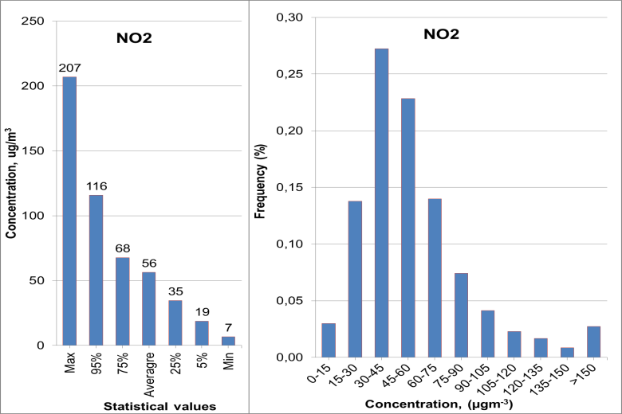
Figure 5. Descriptive statistical values (left panel) and frequency histogram of average value of NO₂ data (right panel).
3.4 The statistical characteristics of O3 concentration
Ground-level ozone (O₃) is a secondary pollutant produced by the reaction between NO₂, volatile organic compounds and sunlight and can induce a variety of health problems such as chest pain, throat irritation, coughing and congestion. The data were obtained from 10 monitoring stations in 4 metropolitan areas, Adana 4, Ankara 3, İstanbul 2 and Kocaeli 1 during 2010-2012 periods. The statistical characteristics and frequency distribution of O₃ concentration are shown in Table 4 and Fig. 6.

Table 4 Descriptive statistical values and frequency histogram for O₃ during 2010-2012.
O₃ |  | Descriptive statistics |  |  |  |  |  |  |  |  |  |  |  | Frequency histograms
City | NS | DAD | Max | 95% | 75% | Average | 25% | 5% | Min | Std | Skw | Kur |  | 0-10 | 10-20 | 20-30 | 30-40 | 40-50 | 50-60 | 60-70 | 70-80 | 80-90 | 90-100 | >100
Adana | 4 | 1077 | 228 | 70 | 45 | 39 | 23 | 10 | 3 | 24 | 3,0 | 15,0 |  | 48 | 154 | 177 | 164 | 90 | 57 | 17 | 4 | 4 | 3 | 5
Ankara | 3 | 1083 | 105 | 76 | 51 | 37 | 17 | 10 | 4 | 21 | 0,6 | -0,5 |  | 58 | 178 | 107 | 106 | 98 | 81 | 51 | 32 | 16 | 2 | 0
İstanbul | 2 | 1007 | 77 | 54 | 39 | 29 | 14 | 5 | 1 | 15 | 0,4 | -0,5 |  | 146 | 152 | 122 | 113 | 89 | 27 | 9 | 2 | 0 | 0 | 0
Kocaeli | 1 | 862 | 183 | 69 | 31 | 26 | 7 | 3 | 1 | 36 | 7,5 | 93,1 |  | 267 | 108 | 42 | 35 | 24 | 13 | 11 | 1 | 1 | 3 | 29
Average |  | 1007 | 148 | 67 | 41 | 33 | 15 | 7 | 2 | 24 | 2,9 | 26,8 |  | 130 | 148 | 112 | 105 | 75 | 45 | 22 | 10 | 5 | 2 | 9

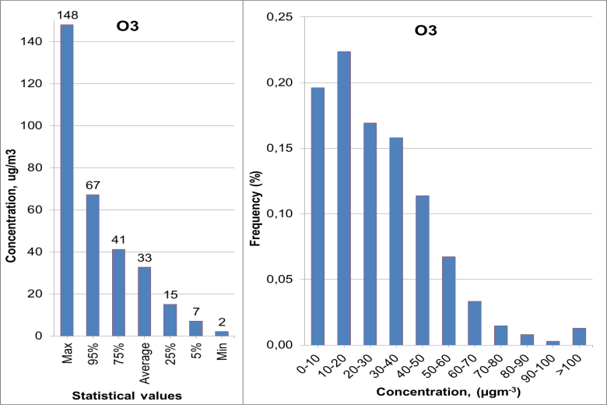
Figure 6. Descriptive statistical values (left panel) and frequency histogram of average value of O₃ data (right panel) for 10 air quality stations from four metropolitan areas in Turkey.
The daily maximum O₃ concentrations range between 228 µgm⁻³ in Adana and 77 µgm⁻³ in İstanbul. The average daily maximum value among all 10 stations is 148 µgm⁻³ and it decreases to 67 µgm⁻³ at 95% percentile, 41 µgm⁻³ at 75%, and 33 µgm⁻³ at 50%, 15 µgm⁻³ at 25%, 7 µgm⁻³ at 5% and 2 µgm⁻³ as the minimum. Standard deviation change between 15 µgm⁻³ in İstanbul and 36 µgm⁻³ in Kocaeli with an average of 24 µgm⁻³ for all stations. The highest and lowest skewness values are 7.5 µgm⁻³ and 0.4 µgm⁻³ at Kocaeli and İstanbul, respectively, with averages of 2.9 µgm⁻³. The kurtosis value is 93.1 µgm⁻³ in Adana and -0.5 µgm⁻³ in Ankara and İstanbul. The frequency distribution of O₃ concentration is given in the same table at intervals of 10 µgm⁻³. A peak in the distribution of daily O₃ concentration occurs most frequently at 22% percentile within 10–20 µgm⁻³ range and another one at 20%, within 0–10 µgm⁻³ range, at 17% in 20–30 µgm⁻³ and at 75% O₃ concentration is less than 40 µgm⁻³.
4. Conclusions and recommendations
Improving air quality requires a great deal of effort such as knowing the air pollution levels and modeling. Studies investigating background air pollution level of cities also will help for offering solutions to environmental pollution problems. This study provides an assessment of the air quality levels for the principal cities in Turkey. The statistical analyses of PM10, SO₂, NO₂ and O₃ data cover the three year period of 2010-2012
including 16 metropolitan areas in Turkey. The results show that the concentration levels of PM10, NO₂ and O₃ in the air do not comply with the EU standards for good health in most of the metropolitan areas, but most cities could be regarded as clean in relation to SO₂ concentrations compared with the EU standards.
In conclusion, observing pollution levels in urban areas offer possible opportunities to manage their sources in a sustainable way, which is required for improving urban air quality. The air quality can be improved by controlling all the major sources including; residential, transportation, commercial and industrial and by planning the future of new urbanization areas. One can hope that the summary of the status of air pollution in principal cities of Turkey will lead to a greater understanding of ambient air quality and the importance of preventing, or reducing its harmful effects on human health and the ecosystem. In order to better address the question of air quality in any society, schools and media outlets must be active in providing educational information for public awareness. As a result, to increase air quality and sustainable living, there’s need for the use of land planning with an air quality perspective and making some strategies such as encouraging houses and businesses to be close to the urban areas.
Acknowledgements
The authors are grateful to Ministry of Environment and Urbanism of Turkey for the air quality data. This study is a background of the online integrated air quality and meteorology modeling project funding by the TUBITAK (Project No: 111Y319) and COST Action ES1004.
References
https://pitt.libguides.com/citationhelp/apa7

∗ Corresponding author : Turkish Airlines, Turkish Aviation Academy, Yesilkoy, İstanbul, Turkey, herdun@thy.com, phone: +90 212 4636363

