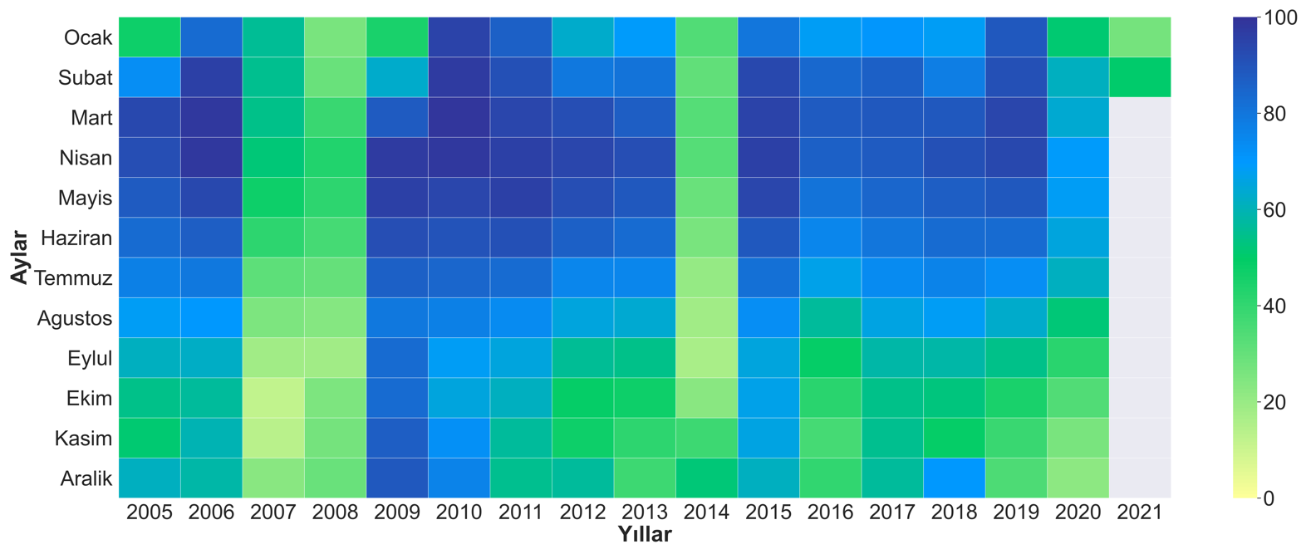
İçindekiler
Effect of Covid-19 Outbreak on Particulate Matter Pollution in Istanbul City Centre
Yağmur Sıla KILIÇ¹, Şükrü DURSUN², Hüseyin TOROS¹
Relationship between air pollution and COVID-19 in Bursa, Turkey
Kübra Yiğiter¹, Hüseyin Toros¹
Relationship Between Air Pollution and COVID-19 measures in İzmir, Turkey
Melike Bilgin¹, Hüseyin Toros¹
The Impact of COVID-19 on Air Quality in the city of Adana, Turkey
Dilan Ҫ. Tunҫ¹, Hűseyin Toros¹
İstanbul Baraj Doluluk Oranlarının Zamansal İncelenmesi ve Çözüm Önerileri
Ferhat Yılmaz^{1*}, İsmail Ulusoy ², Hüseyin Toros ³

